Customer Shopping Behavior Analysis

1.Project Overview
This project analyses customer shopping behavior using transactional data from 3,900 purchases across various product categories. The goal is to uncover insights into spending patterns, customer segments, product preferences, and subscription behavior to guide strategic business decisions.
2.Dataset Summary
- Rows: 3,900
- Columns: 18
- Key Features:
- Customer demographics (Age, Gender, Location, Subscription Status) - Purchase details (Item Purchased, Category, Purchase Amount, Season, Size, Colour) - Shopping behavior (Discount Applied, Promo Code Used, Previous Purchases, Frequency of Purchases, Review Rating, Shipping Type) - Missing Data: 37 values in Review Rating column.
3. Exploratory Data Analysis Using PYTHON
We began with data preparation and cleaning in Python:
- Data Loading : Imported the dataset using pandas.
- Initial Exploration : Used df.info() to check structure and df.describe() for summary statistics.
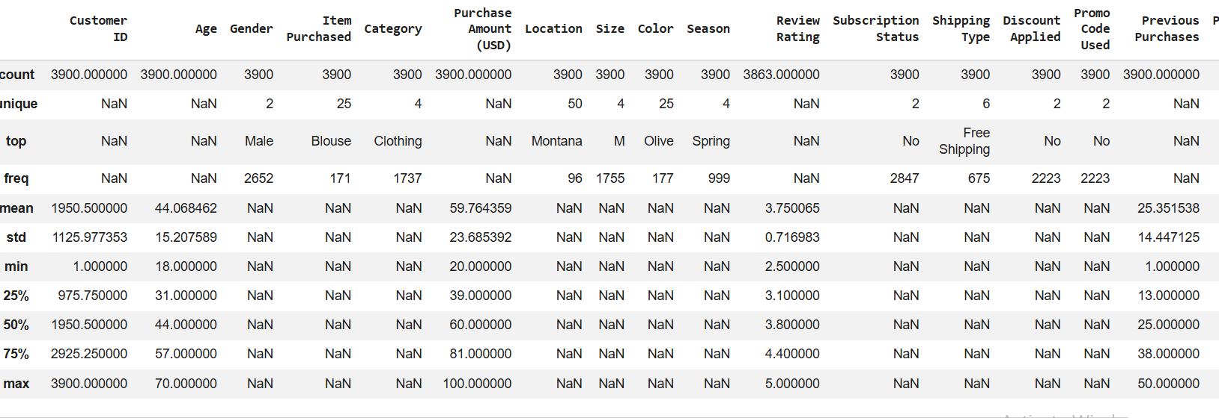
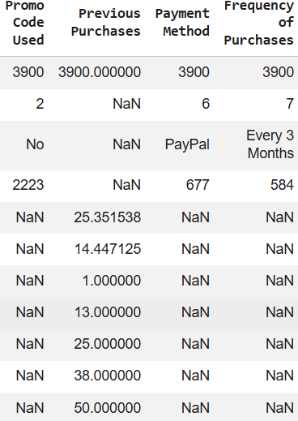
- Missing Data Handling : Checked for null values and imputed missing values in the Review Rating column using the median rating of each product category.
- Column Standardization : Renamed columns to snake case for better readability and documentation.
- Feature Engineering :
- Created age_group column by binning customer ages.
- Created purchase_frequency_days column from purchase data.
- Data Consistency Check : Verified if discount_applied and promo_code_used were redundant ; droped promo_code_used.
- Export Clean Data : Downloaded the cleaned DataFrame as a .csv file directly from Google Colab using df.to_csv('cleaned_data.csv', index=False) and then imported it into MySQL Workbench using the Table Data Import Wizard.

4. Data Analysis Using MySQL(Business Transactions)

We performed structured analysis in MySQL to answer key business questions:

1.Revenue by Gender – ompared total revenue generated by male and female customers.
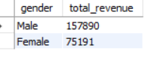

2.High-Spending Discount Users – Identified customers who used discounts but still spend above average purchase amount.
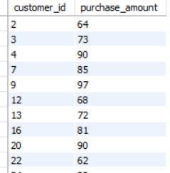

3.Top 5 Products by Rating – Found products with the highest average review rating.

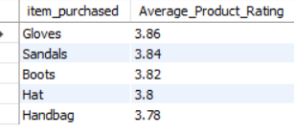

4.Shipping Type Comparison – Compared average purchase amounts between Standard and Express Shipping.

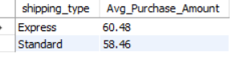

5.Subscribers & Non-Subcribers – Compared average spend and total revenue across subscription status.
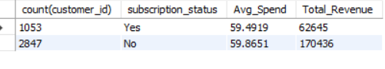

6.Discount-Dependent Products – Identified 5 products with the highest percentage of discounted purchases.
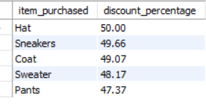

7.Customer Segmentation – Classified customers into New, Returning and Loyal segments on purchase history.
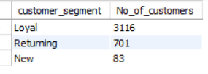

8.Top 3 Products per Category - Listed the most purchased products within each category.
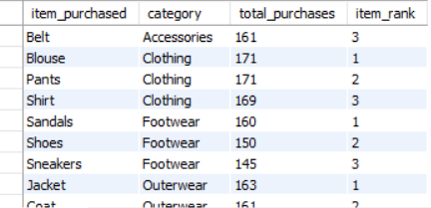

9.Repeat Buyers & Subscriptions – Checked wheather customers with greater than 5 purchases are more likely to subscribe.
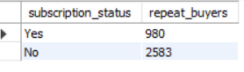

10.Revenue by Age Group – Calculated total revenue contribution of each age group.
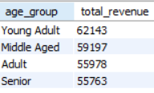

5.Dashboard in Power BI

Finally, we built an interactive dashboard in Power BI to present insights visually.

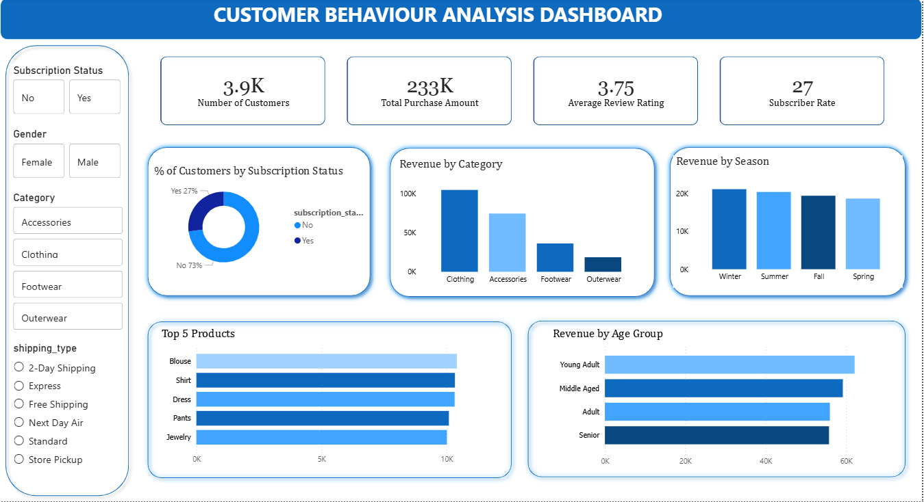

6.Business Recommendations ● Boost Subscriptions – Promote exclusive benefits for subscribers. ● Customer Loyalty Programs – Reward repeat buyers to move them into the “Loyal” segment.
● Review Discount Policy – Balance sales boosts with margin control.
● Product Positioning – Highlight top-rated and best-selling products in campaigns.
● Targeted Marketing – Focus efforts on high-revenue age groups and express-shipping users.

